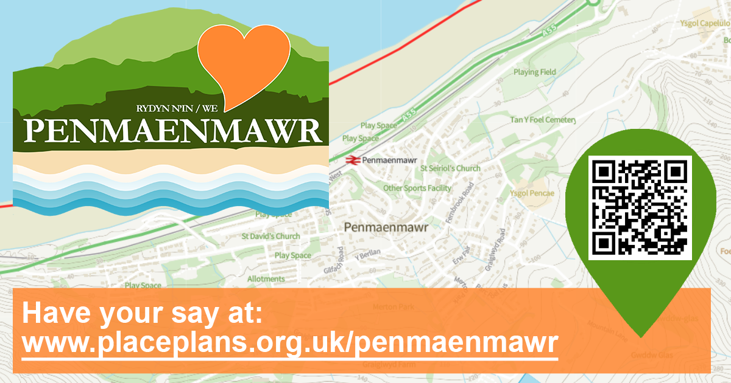

Community Engagement – Feedback to date
The following is a summary of feedback received from the community from the following engagement activities delivered in October 2022, including:
- An engagement event held at Pen Phoenix FC on 2nd October 2022 (15 Participants)
- An engagement event held at Pen Golf Club on 18th October 2022 (5 Participants)
- Results from a first draft online survey published on 16th October (8 responses)
In each activity, we have asked a series of 6 questions and encouraged individuals and groups to generate as many ideas as possible.
These findings have been used to develop a second draft survey which is available to complete at www.planningaidwales.org.uk/penmaenmawr
For more information about the project and opportunities to be involved, please visit www.placeplans.org.uk/penmaenmawr

The ideas below have been submitted by the community of Penmaenmawr.

Question 1: If we had £1million to spend on community projects, what would they be?

Football at Pencae school is poor – improve | New dog agility park
Let the school children play football at the football club as part of school | Flood defences improved by beach and railway
More activities for children | Smarten up Brundrits Wharf
More for youths / different ages | Station road east flood defences
More shelters for youths to meet outside | More outdoor gym equipment - e.g. on prom
More things for kids – youth clubs in Dwygyfylchi and elsewhere | More things to do
Activities for older people / more groups | Outdoor climbing wall
Loneliness a problem – outreach work | Zip line to beach
More community groups and facilities | Dwygyfylchi beach access area
Assist Pen Phoenix to improve facilities | Dwygyfylchi field – have a footpath / running track around the outside
Arcade in Pen | Improve parking at community centre
Puffin café re-open (now in private ownership so it is difficult!) | New bridge to beach (disability friendly)
Dwygyfylchi village hall | Move the skatepark to Kallee Kopec Park
Extend CCTV to Dwygyfylchi | Town Council should take control of the verandah and improve/ extend it to strengthen the look of the centre
Continue Promenade improvements - park / play area | Development of Community Hubs - e.g. Library / Parish Hall
Lots more bins | More Groups for older people
More restaurants | Road into town (both ways) should be improved - flowers and sculptures
Town library expansion and multi-use space | More support for current projects / clubs for older kids /
Improved access to GP surgeries / doctors | Dwygyfylchi community centre to be developed into a multi use venue to meet needs of all age groups and as a base for a range of community activities.
Fitness track with outdoor gym apparatus & distance markers | Reclaiming land lost to erosion at dwygyfylchi beach to make a wider / grassed area and improve sea defences
Purchase of car park by library.

Question 2: What do YOU love about Penmaenmawr?

The village bookshop (second hand books and honesty box) - always open and wonderful. | Shops – parade is pretty and lots of shops and cafes
Beach and Prom are important to the community. | Beach and beach trails (National cycle route)
Fernbrook Car Park is important to the community but should be free to use. | Natural beauty
The Library is an important hub for the community. | Mountains and sea
The Parish Hall is really important for the community and should be brought back into use. | Parks
Foel Lus and the Jubilee Walk | Views
Menai Hirion - The "Druids" Stone Circle | Walks
Penmawnmawr Museum - Fantastic! | Wildlife and natural environment
Parc Plas Mawr - Peaceful | Local shops
Love the town - generally good shops and places to eat. | Beach café
Beach is amazing! - Shame about the A55. | Buses and trains – good service
Everyone is friendly so you feel safe | Central location
Local people are kind | Football club
Town feels safe | Golf club
Dog-friendly | Multi Use Games Area (MUGA) – a good hang out area
Perry Higgins Antiques | Not too touristy but we do have visitors
Pubs | Skatepark
Quietness | The amazing people who give up their time to run clubs for the kids

Question 3: What challenge(s) do you think Penmaenmawr faces - what would you do about them?

Less charity shops and restaurants. Pen needs something different / something to bring people into the area. | Access to NCR for cyclists / access to beach - new bridge
Eroding of Welsh heritage and culture | Safe access to A55 - traffic controls at roundabout
Stop allowing development in conservation area - what is the point of having it if people can just rip it down? | Traffic speeding down Conwy Rd. well over 30mph including Highway Agency vehicles and HGVs
Shops opening hours – stay open longer | Road surface of the A55 is very noisy. You can hear it throughout Pen. Could it have a quieter surface?
Getting people to get involved in community events - engagement / get involved | Access onto A55 at the Puffin roundabout is quite dangerous at peak times because of the speed of the traffic travelling towards Bangor.
Work opportunities for young people - need jobs in the local area/ attract business | General appearance - Add sculptures / flowers / seating etc. at Park Plas Mawr.
Not enough Dentists & Doctors - Welsh Government | Too many small local groups who don't communicate - bring them together to agree a vision
Sheep on the A55 - fencing / cattle grids | Weak economic base - improve the look / attractiveness of the town centre
Dog mess - more dog bins / CCTV | Getting more locals interested in town and using its facilities - marketing / promotion
Park at the end of St David’s does not feel safe - make improvements

Question 4: What do you think are the opportunities that should be developed or made more of in Penmaenmawr?

Fernbrook road car park needs to be improved / doctors surgery is needed in Penmaenmawr | Community events -Swn Y Mor etc
Raise prominence of local walks | Encourage primary schools to use the football club for practice
Encourage hillwalking | Community centre parking needs improving
Multi Use Games Area (MUGA) – open it up for others – a sports Hub – include an outdoor gym | Use the prom and beach to promote the town
Multi Use Games Area - there is an opportunity for the Town Council to work with the football club to provide lights | Emphasise the town's lovely aspect and linkages to Snowdonia
By the Multi Use Games Area – have a park here for younger children – picnics – whilst older children play football. Car parking needed here also – try and encourage car parking at The Dingle and walk to the MUGA | There is a great community spirit with lots of small groups - tap into this
Watersports at the beach | Keep supporting Pen in Blook as the flowers are fantastic and make the town attractive.

Question 5: What should Penmaenmawr look like in 15 years’ time (2037)?

Excellent health care for all | Keep its character
An attractive town centre to encourage a strong economic base - very busy with lots of people using it. | Smart / digital town
A thriving town with lots of facilities on offer for residents and visitors | Well-cared for
A safe and friendly place to live | Green spaces kept as green spaces
Thriving community | A lot of nature and thriving wildlife
More local shops | Got it all in Penmaenmawr (hills and sea – can promote tourism)
Not too much development / buildings | History tours of the quarry
One super school | Push tourism attraction at the Quarry
Puffin café re-opened | Tourism – quarry Zip line
Hill walking | Watersports
Plenty of green space | Zip world and a Sea based attraction
Question 6: How can we reach people in the community?
Suggestions for WHO we should target
Youth | Community groups and clubs
Residents | Schools / colleges
Local businesses | Clubs / Groups

Suggestions on HOW we should reach people
Social media | Incentives – tea and biscuits!
Outreach- go to people – don’t expect people to come to you | Activity or event
Newsletter | Posters for shops etc
Website | Involve community in decisions
Meetings -public engagement | Good communication
Local media | Encourage people to get involved - promote the town / its assets and facilities
Conversation in person | Town Council should have a publicity departments - more than social media
Computer | Need a champion to pull Pen Regeneration forum together - made up of small groups
Local radio / media

