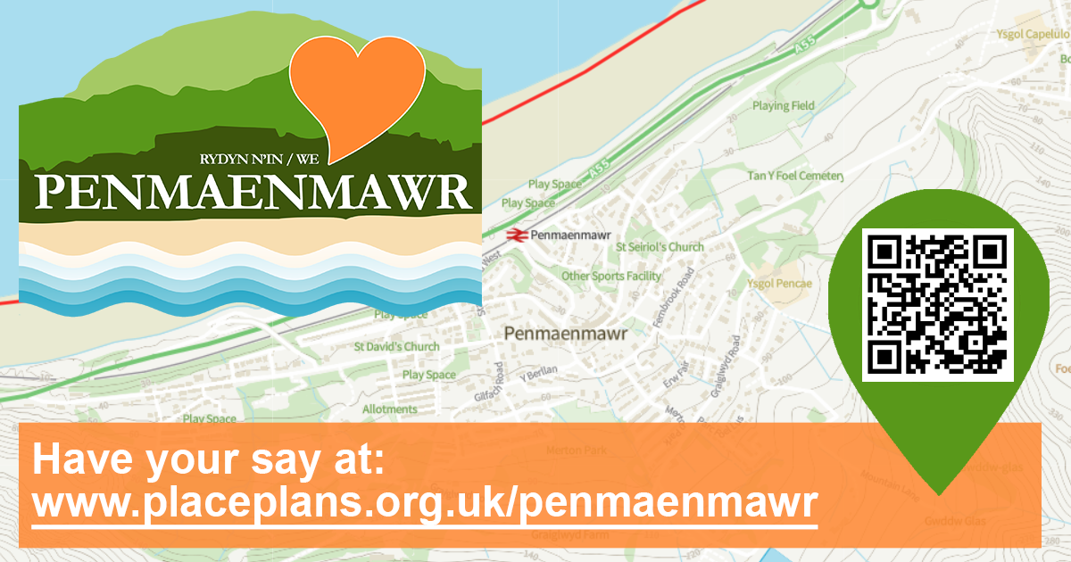

Can you help shape the future of Penmaenmawr?
The Penmaenmawr Kickstarter Place Plan presents an opportunity for local people, working together to influence future decisions.
This survey is open until the 30th November 2022 and we are looking for your views on what could be included in the plan.
If you are filling in a paper copy of this survey, please return it by post or hand it in to: The Town Office and Chamber, Penmaenmawr Community Centre Penmaenmawr Road, Penmaenmawr Penmaenmawr, LL34 6AB or send via email to clerk@penmaenmawr.org
For more information about the Plan please visit
www.placeplans.org.uk/penmaenmawr

The ideas suggested in this survey have been submitted by the community of Penmaenmawr.
This survey should take 10 minutes to complete.
You can complete an electronic version of this survey at www.planningaidwales.org.uk/penmaenmawr

Before we start – about you

Please tick all that apply:
I live within Penmaenmawr
I live outside Penmaenmawr
I am a visitor to Penmaenmawr
I run a business or work in Penmaenmawr

What is your home postcode (this will only be used to check the coverage of the survey):?

Are you part of any local clubs, organisations or groups?
Yes
No

If yes, what local club(s), organisation(s) or community groups are you part of?

Community Project Ideas
Question 1: If we had £1million to spend on community projects, what would they be?

The following ideas have been suggested by the community so far. If you would like to vote on the ideas you agree with most, please do so.

** Please place a tick / cross in the ideas you agree with most (5 maximum).
Community Project Ideas
 | Football at Pencae school is poor – improve |  | New dog agility park
 | Let the school children play football at the football club as part of school |  | Flood defences improved by beach and railway
 | More activities for children |  | Smarten up Brundrits Wharf
 | More for youths / different ages |  | Station road east flood defences
 | More shelters for youths to meet outside |  | More outdoor gym equipment - e.g. on prom
 | More things for kids – youth clubs in Dwygyfylchi and elsewhere |  | More things to do
 | Activities for older people / more groups |  | Outdoor climbing wall
 | Loneliness a problem – outreach work |  | Zip line to beach
 | More community groups and facilities |  | Dwygyfylchi beach access area
 | Assist Pen Phoenix to improve facilities |  | Dwygyfylchi field – have a footpath / running track around the outside
 | Arcade in Pen |  | Improve parking at community centre
 | Puffin café re-open (now in private ownership so it is difficult!) |  | New bridge to beach (disability friendly)
 | Dwygyfylchi village hall |  | Move the skatepark to Kallee Kopec Park
 | Extend CCTV to Dwygyfylchi |  | Town Council should take control of the verandah and improve/ extend it to strengthen the look of the centre
 | Continue Promenade improvements - park / play area |  | Development of Community Hubs - e.g. Library / Parish Hall
 | Lots more bins |  | More Groups for older people
 | More restaurants |  | Road into town (both ways) should be improved - flowers and sculptures
 | Town library expansion and multi-use space |  | More support for current projects / clubs for older kids /
 | Improved access to GP surgeries / doctors |  | Dwygyfylchi community centre to be developed into a multi use venue to meet needs of all age groups and as a base for a range of community activities.
 | Fitness track with outdoor gym apparatus & distance markers |  | Reclaiming land lost to erosion at dwygyfylchi beach to make a wider / grassed area and improve sea defences
 | Purchase of car park by library.

What do we love about Penmaenmawr?
Question 2: What do YOU love about Penmaenmawr?

The following ideas have been suggested by the community so far. If you would like to vote on the ideas you agree with most, please do so.

** Please place a tick / cross in the ideas you agree with most (5 maximum).
What people love about Penmaenmawr
 | The village bookshop (second hand books and honesty box) - always open and wonderful. |  | Shops – parade is pretty and lots of shops and cafes
 | Beach and Prom are important to the community. |  | Beach and beach trails (National cycle route)
 | Fernbrook Car Park is important to the community but should be free to use. |  | Natural beauty
 | The Library is an important hub for the community. |  | Mountains and sea
 | The Parish Hall is really important for the community and should be brought back into use. |  | Parks
 | Foel Lus and the Jubilee Walk |  | Views
 | Menai Hirion - The "Druids" Stone Circle |  | Walks
 | Penmawnmawr Museum - Fantastic! |  | Wildlife and natural environment
 | Parc Plas Mawr - Peaceful |  | Local shops
 | Love the town - generally good shops and places to eat. |  | Beach café
 | Beach is amazing! - Shame about the A55. |  | Buses and trains – good service
 | Everyone is friendly so you feel safe |  | Central location
 | Local people are kind |  | Football club
 | Town feels safe |  | Golf club
 | Dog-friendly |  | Multi Use Games Area (MUGA) – a good hang out area
 | Perry Higgins Antiques |  | Not too touristy but we do have visitors
 | Pubs |  | Skatepark
 | Quietness |  | The amazing people who give up their time to run clubs for the kids

Challenges and possible solutions
Question 3: What challenge(s) do you think Penmaenmawr faces - what would you do about them?

The following ideas have been suggested by the community so far. If you would like to vote on the ideas you agree with most, please do so.

** Please place a tick / cross in the ideas you agree with most (5 maximum).
Challenges and solutions suggested by the community
 | Less charity shops and restaurants. Pen needs something different / something to bring people into the area. |  | Access to NCR for cyclists / access to beach - new bridge
 | Eroding of Welsh heritage and culture |  | Safe access to A55 - traffic controls at roundabout
 | Stop allowing development in conservation area - what is the point of having it if people can just rip it down? |  | Traffic speeding down Conwy Rd. well over 30mph including Highway Agency vehicles and HGVs
 | Shops opening hours – stay open longer |  | Road surface of the A55 is very noisy. You can hear it throughout Pen. Could it have a quieter surface?
 | Getting people to get involved in community events - engagement / get involved |  | Access onto A55 at the Puffin roundabout is quite dangerous at peak times because of the speed of the traffic travelling towards Bangor.
 | Work opportunities for young people - need jobs in the local area/ attract business |  | General appearance - Add sculptures / flowers / seating etc. at Park Plas Mawr.
 | Not enough Dentists & Doctors - Welsh Government |  | Too many small local groups who don't communicate - bring them together to agree a vision
 | Sheep on the A55 - fencing / cattle grids |  | Weak economic base - improve the look / attractiveness of the town centre
 | Dog mess - more dog bins / CCTV |  | Getting more locals interested in town and using its facilities - marketing / promotion
 | Park at the end of St David’s does not feel safe - make improvements

Opportunities for Penmaenmawr
Question 4: What do you think are the opportunities that should be developed or made more of in Penmaenmawr?

The following ideas have been suggested by the community so far. If you would like to vote on the ideas you agree with most, please do so.

** Please place a tick / cross in the ideas you agree with most (5 maximum).
Opportunities suggested by the community

 | Fernbrook road car park needs to be improved / doctors surgery is needed in Penmaenmawr |  | Community events -Swn Y Mor etc
 | Raise prominence of local walks |  | Encourage primary schools to use the football club for practice
 | Encourage hillwalking |  | Community centre parking needs improving
 | Multi Use Games Area (MUGA) – open it up for others – a sports Hub – include an outdoor gym |  | Use the prom and beach to promote the town
 | Multi Use Games Area - there is an opportunity for the Town Council to work with the football club to provide lights |  | Emphasise the town's lovely aspect and linkages to Snowdonia
 | By the Multi Use Games Area – have a park here for younger children – picnics – whilst older children play football. Car parking needed here also – try and encourage car parking at The Dingle and walk to the MUGA |  | There is a great community spirit with lots of small groups - tap into this
 | Watersports at the beach |  | Keep supporting Pen in Blook as the flowers are fantastic and make the town attractive.

Penmaenmawr in 15 years’ time (2037)
Question 5: What should Penmaenmawr look like in 15 years’ time (2037)?

The following ideas have been suggested by the community so far. If you would like to vote on the ideas you agree with most, please do so.

** Please place a tick / cross in the ideas you agree with most (5 maximum).
Suggestions for what Penmaenmawr should look like in 2037
 | Excellent health care for all |  | Keep its character
 | An attractive town centre to encourage a strong economic base - very busy with lots of people using it. |  | Smart / digital town
 | A thriving town with lots of facilities on offer for residents and visitors |  | Well-cared for
 | A safe and friendly place to live |  | Green spaces kept as green spaces
 | Thriving community |  | A lot of nature and thriving wildlife
 | More local shops |  | Got it all in Penmaenmawr (hills and sea – can promote tourism)
 | Not too much development / buildings |  | History tours of the quarry
 | One super school |  | Push tourism attraction at the Quarry
 | Puffin café re-opened |  | Tourism – quarry Zip line
 | Hill walking |  | Watersports
 | Plenty of green space |  | Zip world and a Sea based attraction

Reaching people
Question 6: How can we reach people in the community?

The following ideas have been suggested by the community so far. If you would like to vote on the ideas you agree with most, please do so.

Suggestions for WHO we should target – please tick / cross 3 only!
 | Youth |  | Community groups and clubs
 | Residents |  | Schools / colleges
 | Local businesses |  | Clubs / Groups

Suggestions on HOW we should reach people - please tick 5 only!
 | Social media |  | Incentives – tea and biscuits!
 | Outreach- go to people – don’t expect people to come to you |  | Activity or event
 | Newsletter |  | Posters for shops etc
 | Website |  | Involve community in decisions
 | Meetings -public engagement |  | Good communication
 | Local media |  | Encourage people to get involved - promote the town / its assets and facilities
 | Conversation in person |  | Town Council should have a publicity departments - more than social media
 | Computer |  | Need a champion to pull Pen Regeneration forum together - made up of small groups
 | Local radio / media

Anything we’ve missed?
Please leave your ideas / comments below:

Thank you for taking the time to complete this survey.

Please tick all that apply
 | You would like to be added to the Penmaenmawr Plan mailing list to be kept informed of progress and future consultations. |  | You are a member of a local group and can help to distribute information and news about the Plan to your group members.
 | You are interested to find out more about how you might get involved in contributing your local knowledge in areas that interest you.

If you have ticked any of the above, please provide your name & email address so we can get in touch.
Name:

Email Address:

*Any personal data you provide such as your contact details, will only be used by Penmaenmawr Town Council to contact you about Town Council business. We will not share any personal data with 3rd parties.

If you are filling in a paper copy of this survey, please return it by post or hand it in to: The Town Office and Chamber, Penmaenmawr Community Centre Penmaenmawr Road, Penmaenmawr Penmaenmawr, LL34 6AB or send via email to clerk@penmaenmawr.org

